Navigating Professional Waters:
Mastering Crucial Conversations, Fostering Proactive Conflict Resolution & Cultivating Career Growth
A continuing education course sponsored by the Michigan Chapter of the American Fisheries Society

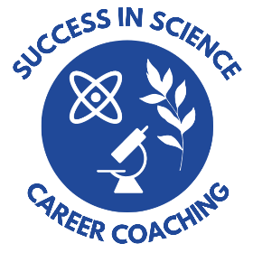
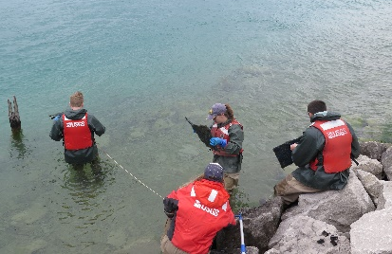
March 20, 2024
Kellogg Hotel and Conference Center East Lansing, Michigan

USGS

Instructed by Dr. Cassie M. Briggs CPCC (Success in Science Career Coaching)

Course Description

Join us for an engaging and transformative workshop designed for students, emerging and established professionals interested in honing essential skills for building a successful and fulfilling career in fisheries. Through a combination of individual reflective exercises and interactive group activities, attendees will master the intricacies of crucial conversations, harness proactive conflict resolution strategies, and build foundational skills that promote continued professional growth.

Led by an established conservation biologist and certified professional development coach, this workshop offers a comprehensive exploration of communication techniques tailored to high-stakes situations encountered in professional settings and conservation work. Participants will learn the art of steering conversations toward constructive outcomes, effective approaches to giving and receiving feedback, and clarify metrics to maximize their professional success, the success of their teams, and of larger conservation initiatives.

Unlock your potential and gain practical insights to navigate professional waters with confidence and finesse. Don’t miss this opportunity to elevate your skills and propel your career (and your team) forward.

Where – Kellogg Hotel and Conference Center, East Lansing MI

When – Wednesday March 20th from 1 pm to 4 pm

Cost – $20 for students (up to five students will receive free registration, see following workshop award form), $70 for MIAFS members, and $100 for non-MIAFS members.

What to Bring – Attendees are encouraged to bring a device with internet access to fully engage and participate in workshop activities.

This workshop will follow current COVID CDC guidelines and is subject to change. Please be prepared to wear a mask during the lecture portion and follow social distancing guidelines if applicable.

Lodging arrangements are not included with course registration. Hotel reservations can be made at the Kellogg Hotel and Conference Center (219 S Harrison Rd, East Lansing, MI 48824) by going to https://kelloggcenter.com/hotel and using block code 2403AMERIC or by calling (517) 432-4000 to get the group rate of $135+ tax/night or use with. Block will be released on Feb 19, 2024.

To register for this workshop please follow this link.

If you encounter problems with the link or have questions, contact Stacey Ireland at sireland@usgs.gov. Please include your name, affiliation/organization, and MIAFS membership status (member/non-member/student). If will be attending the MIAFS annual meeting there will be a question asking if you wish to attend and the above form will be sent to you. After registering you will receive an invoice with instructions for paying via check or PayPal. Class size is limited to 25 participants. Please register by March 13th.
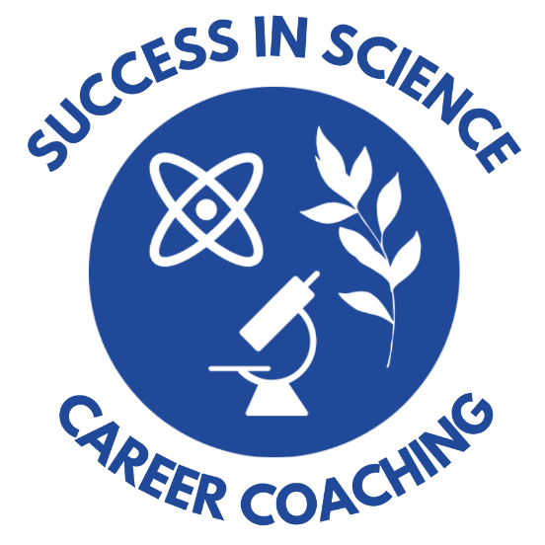
Student Award and Travel Grant

Navigating Professional Waters:
Mastering Crucial Conversations, Fostering Proactive Conflict Resolution & Cultivating Career Growth

Description: Reimbursement for workshop registration fee. Registration fee must be paid in advance and will be reimbursed upon successful completion of the workshop. Awarded applicants will also receive an additional travel grant of up to $300. Award is subject to number of applicants.

Purpose: To financially assist students who are interested in attending the Navigating Professional Waters workshop.

Eligibility criteria: The recipient of this award must be currently enrolled in a degree program at a college or university.

Documentation required: An application letter from the student nominee that includes: student’s name, address, telephone number, educational institution, department, degree level, reasons for attending the workshop, and reasons for financial need if necessary.

Selection criteria: The committee will evaluate the applicants based on the following criteria: 1) AFS involvement, 2) Reasons for attending the workshop, 3) Financial need.

Frequency of Award: Five workshop seats will be held for successful applicants until the application deadline. Awarded applicants will also receive an additional travel grant of up to $300.

Deadline: Applications must be received by the Continuing Education Committee (Stacey Ireland, sireland@usgs.gov) by March 13th, 2024.

Applications will be forwarded to the Student Concerns Committee for review. Selections will be forwarded to the Chapter president, Continuing Education Committee, and the secretary-treasurer for notification. The secretary-treasurer will provide award directly to the selected recipients after successful completion of the workshop.

